Rebuilding Together Spokane Website

Team: Justin, Jason, Jason, Michael

**Pre-outline of project**

**Description:** We will be designing a website for Rebuilding Together Spokane, one of 166 national affiliates. This site will allow them to display in an orderly fashion what their organization is all about and how it is serving the community around Spokane. Also it will allow for people to request help as well as the ability to serve as a volunteer.

**Marketing:** So as for this project we are targeting two major groups, 1. The elderly and their families who are in need of help and services from Rebuilding Together, and 2. Volunteers/Sponsors who want to donate time and or money to helping build this up.

**Requirements:** As for requirements when talking with the client the prioritized pages were:

* Home Page – this includes the Mission statement with photos
* Programs Page – includes National Rebuilding Day and how it serves the community, and how to apply for help (services)
* About Us Page – Bios of all the board members with photos
* Volunteers Page – Contact info to become a volunteer
* Services Page – How to donate, as well as other sponsors

**Test Plan:** To show that this project was successful we want to produce a product “Rebuilding Together Spokane” that is approved by the board committee and eventually when financially available, we can secure the domain and launch the actual website.

**Mock-Up:** Structure wise, our client wants Tab menu system across the top, with each subject as a tab, and possible drop down tabs as well.

| Home | About | Programs | Volunteer | Support | - with drop down tabs in the “About”, “Programs” and “Support” tabs.

(We’ve included a rough sketch).

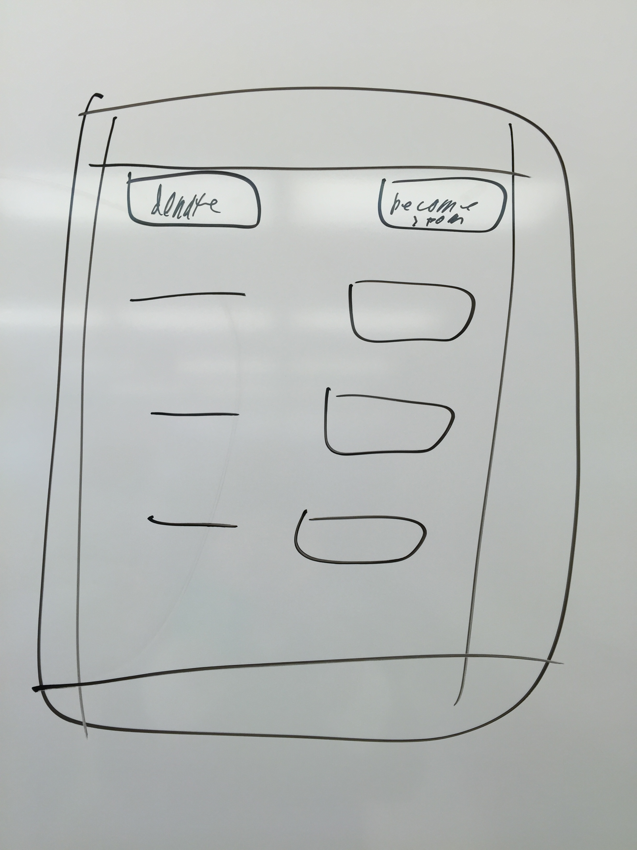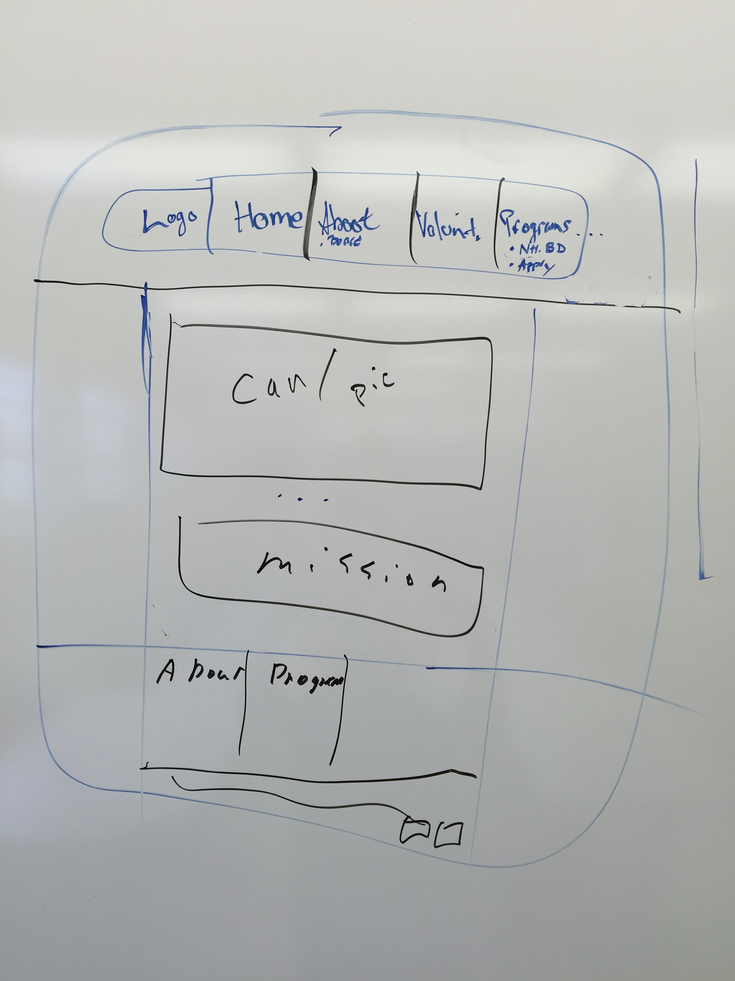

We also want to include social media links (tiles). Also we want to use a picture carousel that will be used on the main page as a focal point.

As for styling we want it to be modern looking but still very clean and true to the organization, so sticking with the organization’s fundamental colors and logo.

**Software Design:**

For this project there is a great amount of static information on the website that will not need much management. However here are a few of the major dynamic characteristics.

Dynamic Characteristics:

* Contact Info – can be updated as changes occur
* Applications (services & volunteers)
* Sponsors – as they change every year
* Photos
* Board members

Due to these requests we will need to definitely use JavaScript (especially for movement). However something we are going to look into, because this is a CMS, is Word-press and see how that might be a feasible option for our client.